**Electrical Measurements**

**UNIT- II**

**2.1. Permanent Magnet Moving Coil Instrument (PMMC) :**

|  |
| --- |
| The permanent magnet moving coil instrument is the most accurate type for D.C. Measurements. The working principle of these instruments is the same as that of the d’Arsonval type of galvanometers, the difference being that a direct reading instrument is provided with a pointer and a scale  Image result for pmmc  Fig.2.1. Construction of PMMC Instrument  **2.1.1 Construction of PMMC Instruments** :  The constructional features of this instrument are shown in Fig. The moving coil is wound with many turns of enameled or silk covered copper wire. The coil is mounted on rectangular aluminum former, which is pivoted on jeweled bearings. The coils move freely in the field of a permanent magnet. Most voltmeter coils are wound on metal frames to provide the required electro-magnetic damping. Most ammeter coils, however, are wound on non-magnetic formers, because coil turns are effectively shorted by the ammeter shunt. The coil itself, therefore, provides electro magnetic damping. Magnet Systems Old style magnet system consisted of relatively long U shaped permanent magnets having soft iron pole pieces. Owing to development of materials like Alcomax and Alnico, which have a high co-ercive force, it is possible to use smaller magnet lengths and high field intensities. The flux densities used in PMIMC instruments vary from 0.1 Wb/m to 1 Wb/m.  **2.1.2.Control**  When the coil is supported between two jewel bearings two phosphor bronze hairsprings provide the control torque.  These springs also serve to lead current in and out of the coil. The control torque is provided by the ribbon suspension as shown.  This method is comparatively new and is claimed to be advantageous as it eliminates bearing friction.  **2.1.3.Damping**  Damping torque is produced by movement of the aluminum former moving in the magnetic field of the permanent magnet.  **2.1.4.Pointer and Scale**  The pointer is carried by the spindle and moves over a graduated scale. The pointer is of lightweight construction and, apart from those used in some inexpensive instruments has the section over the scale twisted to form a fine blade. |

This helps to reduce parallax errors in the reading of the scale. When the coil is supported between two jewel bearings two phosphor bronze hairsprings provide the control torque. These springs also serve to lead current in and out of the coil.

#### ****2.1.5.Torque Equation for**** [PMMC Instruments](http://electricalbaba.com/pmmc-instruments-construction-working-principle/)****:****

The deflecting torque equation for Permanent Magnet Moving Coil or [PMMC Instruments](http://electricalbaba.com/pmmc-instruments-construction-working-principle/) is given as

***Deflecting Torque Ƭd = NBLdI = GI***

Where G = a constant = NBLd

Where N = Number of turns in the moving coil

B = magnetic flux density between the magnetic poles

L = Length of moving coil

d = Breadth of moving coil

As the controlling torque is provided by the spring, therefore

***Ƭc = KƟ***

Where K = Spring constant

Ɵ = Angular movement of coil

At steady state condition, deflecting and controlling torque shall be equal,

Ƭd = Ƭc

⇒ GI = KƟ

⇒***Ɵ = (G / K)I*** ……………………(1)

Thus from the above equation (1), we observe that deflection in Permanent Magnet Moving Coil or [PMMC Instruments](http://electricalbaba.com/pmmc-instruments-construction-working-principle/) is directly proportional to the current flowing in the moving coil. Because of this the meter scale of such instrument for the measurement of current / voltage is linear.

### 2.1.5.Errors in Permanent Magnet Moving Coil Instruments

There are three main types of errors:

1. **Errors due to permanent magnets:** Due to temperature effects and aging of the magnets the magnet may lose their magnetism to some extent. The magnets are generally aged by the heat and vibration treatment.
2. Error may appear in PMMC Instrument due to the aging of the spring. However the error caused by the aging of the spring and the errors caused due to permanent magnet are opposite to each other, hence both the errors are compensated with each other.
3. **Change in the resistance of the moving coil with the temperature:** Generally the temperature coefficients of the value of coefficient of copper wire in moving coil is 0.04 per degree celsius rise in temperature. Due to lower value of temperature coefficient the temperature rises at faster rate and hence the resistance increases. Due to this significant amount of error is caused.

### Advantages of Permanent Magnet Moving Coil Instruments

1. The scale is uniformly divided as the current is directly proportional to deflection of the pointer. Hence it is very easy to measure quantities from these instruments.
2. Power consumption is also very low in these types of instruments.
3. Higher value of torque is to weight ratio.
4. These are having multiple advantages, a single instrument can be used for measuring various quantities by using different values of shunts and multipliers.

Instead of various advantages the permanent magnet moving coil instruments or **PMMC Instrument**posses few disadvantages.

### Disadvantages of Permanent Magnet Moving Coil Instruments

1. These instruments cannot measure ac quantities.
2. Cost of these instruments is high as compared to [moving iron instruments](https://www.electrical4u.com/moving-iron-instrument/).

**2.2.Moving Iron Instrument:**

Moving Iron Instruments are the most common type of ammeter and voltmeter used at power frequencies in laboratories. These instruments are very accurate, cheap and rugged as compared to other AC instruments.

#### 2.2.1.[Working Principle of Moving Iron Instruments](http://electricalbaba.com/working-principle-moving-iron-instruments/):(MI Attraction type instrument):

In Moving Iron Instruments, a plate or van of soft iron or of high permeability steel forms the moving element of the system. The iron van is so situated that it can move in the magnetic field produced by a stationary coil. Figure below shows a simple moving iron instrument.

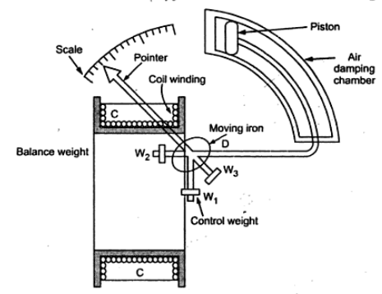

Fig.2.2.Moving Iron Attraction type instrument

The stationary coil is excited by the current or voltage under measurement. When the coil is excited, it becomes an electromagnet and the iron van moves in direction of offering low reluctance path. Thus the force of attraction is always produced in a direction to increase the inductance of coil. Mind that as the van follows the low reluctance path, the net flux in air gap will increase which means increased flux linkage of coil and hence inductance of coil will increase. It shall also be noticed that, the inductance of coil is variable and depends on the position of iron van.

**2.2.2. Repulsion Type**

One vane is rigidly attached to the coil frame while the other can rotate coaxially inside the stationary vane, as shown in Fig. 2.9. Both vanes are magnetized by the current in the coil to the same polarity, causing the vanes to slip laterally under repulsion. Because the moving vane is attached to a pivoted shaft, this repulsion results in a rotational force that is a function of the current in the coil. As in other mechanisms the final pointer position is a measure of the coil current. Since this movement, like all iron vane instruments, does not distinguish polarity, the concentric vane may be used on dc and ac, but it is most commonly used for the latter.

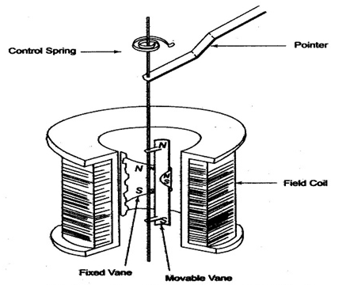

Fig.2.3.Moving iron repulsion type instrument

**2.2.3.Torque Equation of Moving Iron Instruments**

Suppose that, at any instant of time current flowing in the coil is I. Thus the energy stored in the coil in the form of magnetic field = (1/2)LI2.

As soon as the current changes to (I+dI), deflection in the pointer becomes dƟ resulting into change in inductance of coil from L to (L+dL). Let this deflection in pointer is due to deflection torque Td.

Thus mechanical work done = Tdx dƟ ………………..(1)

Energy stored in Coil = (1/2)(L+dL)(I+dI)2

Change in stored energy of coil

= Final Stored Energy – Initial Stored Energy

= (1/2)(L+dL)(I+dI)2 – (1/2)LI2

= (1/2)[ (L+dL)(I+dI)2 – I2L]

= (1/2)[ (L+dL)(I2+2IdI+(dI)2 – I2L]

= (1/2)[ LI2+2LIdI+L(dI)2+ dLxI2+2IdIxdL+dLx(dI)2   – I2L]

Neglecting second order and higher terms of differential quantities i.e. L(dI)2, 2IdIxdL and dLx(dI)2

= (1/2)[ 2LIdI+dLxI2]

= LIdI +(1/2)dLx I2  ……………………(2)

Again, just think, when there is a change of current from I to (I+dI), this change change of current must be accompanied by change in emf of coil. Thus we can write as

e = d(LI) / dt

   = IdL/dt + LdI/dt

But electrical energy supplied by the source = eIdt

                                                                        = (IdL + LdI) x I

                                                                        = I2dL + LIdI

According to law of conservation of energy, this electrical energy supplied by the source is converted into stored energy in the coil and mechanical work done for deflection of needle of Moving Iron Instruments.

Hence,

I2dL + LIdI = Change in stored energy + Work done

⇒ I2dL + LIdI = LIdI +(1/2)dLx I2  + Tdx dƟ  ….[from (1) and (2)]

⇒ Tdx dƟ = (1/2)dLxI2

⇒ ***Td = (1/2)I2(dL/dƟ)***

Thus deflecting torque in Moving iron Instruments is given as

***Td = (1/2)I2(dL/dƟ)***

From the above torque equation, we observe that the deflecting torque is dependent on the rate of change of inductance with the angular position of iron van and square of rms current flowing through the coil.

In moving iron instruments, the controlling torque is provided by spring. Controlling torque due to spring is given as

Tc = KƟ

Where K = Spring constant

Ɵ = Deflection in the needle

In equilibrium state, deflecting and controlling torque shall be equal as shown below.

Deflecting Torque = Controlling Torque

⇒ Td = Tc

⇒ (1/2)I2(dL/dƟ) = KƟ

⇒ ***Ɵ = (1/2)(I2/K)(dL/dƟ)***

From the above torque equation, we observe that the angular deflection of needle of moving iron instruments is square of rms current flowing through the coil. Therefore, the deflection of moving iron instruments is independent of direction of current.

**2.3.Thermal Type Instruments:**

There are mainly two types

1.Hot wire instrument

2.Thermal electric Instrument

**2.3.1.Hot Wire Instruments**

The hot wire instruments are based on the principle that length of wire increases due to heating effect when a current passed through it. It is a square law device with a non-linear relationship because increase in length of a wire is directly proportional to the square of current passing through wire. Note that the increase in the length of a wire is very small percentage of the total length of wire. Hence various mechanical linkages have been devised to expand this effect and convert it into motion of a point of a circular scale.

**Construction and operation:**

The constructional details of a hot-wire double sag type instruments are as shown in the Fig. 2.4

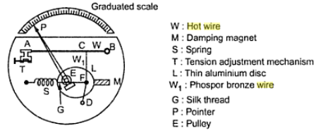

Fig2.4.Hot wire instrument

A hot working wire denoted by W in the Fig.1 is made up of  platinum-irridum alloy. The main advantages of using platinum-irridum alloy is that it can withstand high temperatures without deterioration of wire material caused by oxidation. The working wire W is very fine and its diameter is of the order of 0.1 mm. The wire W is stretched between two point A and B where point B is fixed point and point A is tension adjustment point at which tension adjustment mechanism is placed. One more wire W1, made up of phosphor-bronze is connected to main hot wire W at point C while other end of wire W1is connected to fixed point D. A fine thread of silk material represented by G is connected between spring S and point F. The thread G is wound around a pulley denoted by E. Both points F and spring S are fixed points. A point P used for indication and thin aluminium disc L are mounted on the spindle. The pulley system E is also mounted on the spindle.

       When a current to be measured is passed through the wire, it gets expanded as a result of heating effect by current flowing through it. Because of heating effect, a sag is produced in the wire W. Now the sag in main working wire W causes sag in other wire W1. This sag is transferred to the spring S through a fine silk thread G. Thus the sag produced gets magnified and the spring activates pulley to rotate and pointer gets deflected indicating value of the current under measurement on a graduated scale.

       The expansion of the wire is proportional to the heating effect of the current. As heat produced is in the form of power dissipated give P = I2R , the expansion of the wire in hot wire instrument is proportional to the square of r.m.s. value of the current. A thin aluminium disc L rotates between poles of the permanent magnet M and it provides eddy current  damping to the instrument. The base of the main instrument is made up of a material which is having coefficient of expansion same as that of hot wire. As base and hot wire, both have same coefficient of expansion, the errors due to uneven expansion between base of instrument and hot wire are minimized.

       In early hot wire instruments, the hot wire used was made up of platinum-silver alloy. But the main drawback of early instruments was the low value of the full-scale operating temperature ( about 135-150 oC). Because of very low operating temperature, even small variations in room temperature affects the position of the pointer. Today's hot wire instruments use wire made up of platinum-irridum alloy with which operating temperature range can be extended upto 300 to 500 oC. As the temperature range is increased, the effects due to room temperature variations are minimized. The hot wire is made very thin so that it can attain steady temperature quickly when current flows through wire. The size of wire is decided such that it can bare normal mechanical stresses developed in the instruments.

       The hot wire instrument can be used as ammeter over a range 0 to 1 A without a shunt, while 0 to 5 A with a shunt. It can be used as a voltmeter to measure voltage upto 400 V by using high value non-inductive resistance in series with instruments.

### Advantages of the Hot Wire Instrument:

The following are the advantage of the hot wire instrument.

1. The instrument is used for both AC and DC measurement.
2. It is a transfer-type instrument i.e, the calibration is same for both the AC and DC measurement.
3. The hot wire instrument is free from the stray magnetic field.
4. Their construction is very simple and cheap.

### Disadvantages of Hot Wire Instrument:

The following are the disadvantages of the hot-wire instrument.

1. The Hot Wire instrument gives the slow response.
2. The instability occurs in the instruments because of the stretching of the wire.
3. The instrument consumes more power.
4. The instrument is not able to withstand under overload and mechanical shock.

Because of the above mention disadvantage, the instruments are replaced by the Thermo-electric instruments.

**2.3.2.Thermoelectric instrument:**

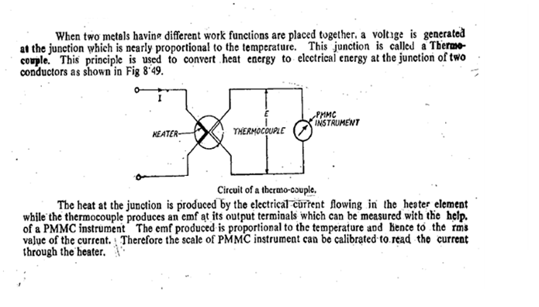

### Advantages of thermoelectric Instrument

The following are the advantages of thermoelectric Instrument.

1. This type of instrument is free from the stray magnetic field.
2. The instrument has a high sensitivity.
3. It is useful for the calibration of the potentiometer with the help of the standard cell.
4. These instruments are free from the frequency error and hence used for the widest range of frequency.

### Disadvantages of thermoelectric Instrument

The only disadvantage of the thermoelectric instrument is that their overload capacity is less as compared to the other element.

# 2.4.Rectifier Type Instrument:

**Definition:** The instrument which uses the rectifying element for measuring the voltage and current is known as the rectifying instruments. The **rectifying element converts the alternating current to the direct current which indicates by the DC responsive meter**. The PMMC uses as an indicating instrument.

The sensitivity of the rectifying instruments is high as compared to the moving coil and the Electrodynamometer instrument. Thereby, it uses for measuring the current and voltage. The circuit arrangement of the rectifier instrument shown in the figure below. The device uses the four diodes which act as a rectifying element.

[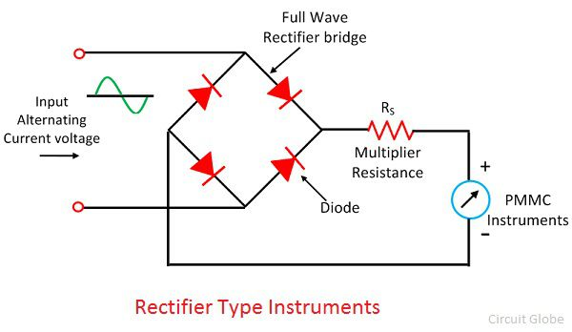](https://circuitglobe.com/wp-content/uploads/2017/11/rectifier-type-instruments.jpg)

The multiplier [resistance](https://circuitglobe.com/what-is-a-resistance.html) Rs uses for limiting the value of current so that their value does not extend more than the rating of the [PMMC instrument](https://circuitglobe.com/permanent-magnet-moving-coil-or-pmmc-instrument.html)

## Rectifying Element

The rectifier element is used for the conversion of the AC to DC so that the unidirectional current flows through the PMMC instrument. The copper oxide, selenium cell, germanium and silicon diode are uses for making rectifying element.

**The rectifying element offers the zero resistance when it is in forwarding bias and infinite resistance when it is in reverse biased**. This property of the rectifying element use for rectification purpose.

### Characteristic Curve of Rectifying Element

The characteristic curve of the rectifying circuit shown in the figure below. Ideally, the rectifying instrument does not have any voltage drops in the forward direction and no current flows in the reverse direction.

[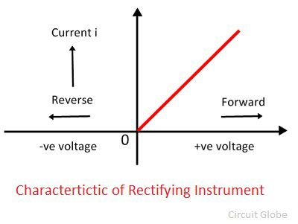](https://circuitglobe.com/wp-content/uploads/2017/11/characteristic-of-ideal-instrument.jpg)

But practically, this is not possible. The real characteristic curve of the rectifying element shown in the figure below.

[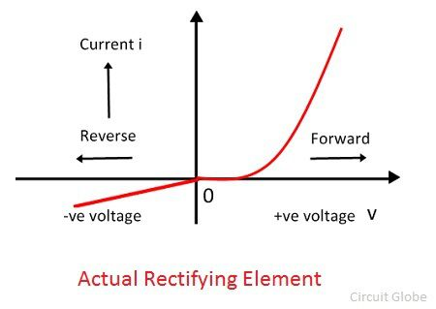](https://circuitglobe.com/wp-content/uploads/2017/11/actual-rectifying-diode-1.jpg)

### Half Wave Rectifier Circuit:

The figure below shows the half-wave rectifying circuit. The rectifying element connects in series with the voltage source, resistance multiplier and the permanent moving coil instrument. The forward resistance of the diode is neglected.

[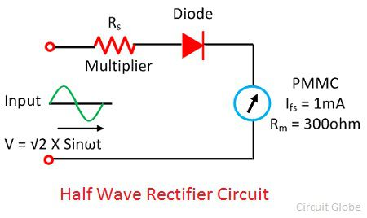](https://circuitglobe.com/wp-content/uploads/2017/11/half-wave-rectifier.jpg)

When the DC voltage source applies to the circuit, the Im current flows through it. The magnitude of the current is equal to the V/(Rm+RS). The current shows the full-scale deflection to the instrument.

The AC voltage applies to the same circuit. The rectifying element converts the AC voltage into unidirectional DC voltage. Thus, the rectified output voltage obtains through the rectify instrument. The PMMC instrument deflects through the average value of current which depends on the average voltage of the apparatus.

[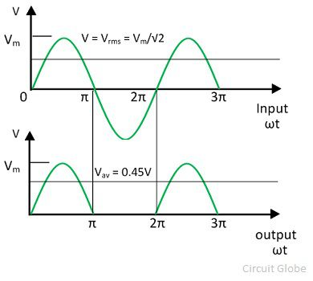](https://circuitglobe.com/wp-content/uploads/2017/11/half-wave-rectifier-graph.jpg)

Average Value of Voltage

[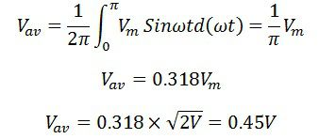](https://circuitglobe.com/wp-content/uploads/2017/11/half-wave-rectifier-circuit.jpg)

The above calculation shows that the sensitivity of the instrument through AC is 0.45 times the current through the sensitivity of DC.

### Full Wave Rectifier Instrument:

The circuit of full wave rectifier shown in the figure below.

[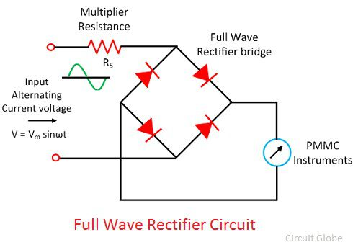](https://circuitglobe.com/wp-content/uploads/2017/11/full-wave-rectifier-circuit.jpg)

The DC voltage applied to the circuit causes the full-scale deflection of the PMMC meter. The sinusoidal voltage applies to the meter express as  
[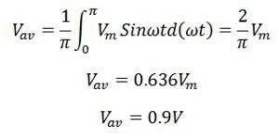](https://circuitglobe.com/wp-content/uploads/2017/11/equation-1.jpg)

The average calculation of AC is 0.9 times with that of the DC for the same value of voltage. Or we can say that the sensitivity of the instrument along with AC is 90% with that of the DC.

[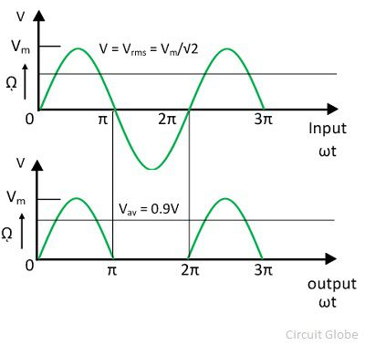](https://circuitglobe.com/wp-content/uploads/2017/11/full-wave-rectifier-graph.jpg)

The sensitivity of the full wave rectifier is double to that of the half wave rectifier instrument.

### Sensitivity of Rectifier Instrument:

The sensitivity of the instrument shows the variation of the measured quantity from input to output. The DC sensitivity of the rectifier instrument

[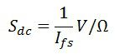](https://circuitglobe.com/wp-content/uploads/2017/11/senstivity.jpg)

The sensitivity of the AC rectifier type instrument depends on the type of the rectifying element use in the circuit.

### Advantages of Rectifying Instrument:

The following are the advantages of the rectifiers instruments.

1. The frequency range of the instruments increases from 20HZ to high-frequency range.
2. The current operating range for such type of instrument is much lower for [voltmeter](https://circuitglobe.com/voltmeter.html) as compared to the other AC instrument.
3. The instrument has uniform scales for the large range.

The accuracy of the instrument is ±5 percent when it is in normal operating condition

**2.5.Basic D.C. Ammeter:**

The basic d.c. ammeter is nothing but a D'Arsonval galvanometer. The coil winding of a basic     movement is very small and light and hence it can carry very small current. For large currents, the major part of current is required to bypassed using a resistance called shunt. It is shown in the Fig. 2.5.

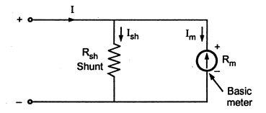

Fig.2.5.Basic D.C Ammeter

The shunt resistance can be calculated as :

       Let      Rm= Internal resistance of coil

          Rsh= Shunt resistance

          Im= Full scale deflection current

          Ish= Shunt current

          I   = Total current

       Now I =  Ish + Im

       As the two resistances Rsh and Rmare in parallel, the voltage drop across them is same.

[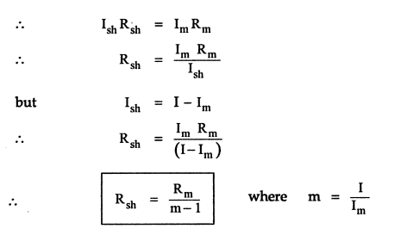](http://3.bp.blogspot.com/-5NCPA-4eWc8/U3TVltRmpZI/AAAAAAAANRo/4lJ9Hm2kANA/s1600/d12.png)

The m is called multiplying power of the shunt and defined as the ratio of total current to the current through the coil. It can be expressed as,

[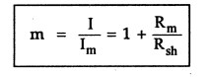](http://1.bp.blogspot.com/-cyOaQxXV9nw/U3TV4kpL8TI/AAAAAAAANRw/kiu_UZohPjs/s1600/d13.png)

       The shunt resistance may consist of a constant temperature resistance wire within the case of the meter or it may external shunt having low resistance.

       Thus to increase the range of ammeter 'm' times, the shunt resistance required is 1/(m-1) time the basic meter resistance. This is nothing but extension of ranges of an ammeter.

### 2.6.Multirange Ammeter

The range of the basic d.c. ammeter can be extended by using number of shunts and a selector switch. Such ammeter is called multirange ammeter. and is shown in the Fig. 2.6.

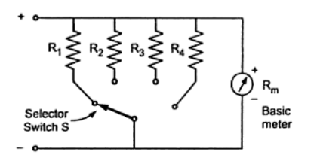

Fig2.6.Multirange Ammeter

 R1,R2, R3and R4 are four shunts. When connected in parallel with the meter, they can give four different ranges I1,I2, I3and I4. The selector switch S is multiposition switch, having low contact resistance and high current carrying capacity. The make before break type switch is used for the range changing.

       If the ordinary switch is used, while range changing the switch remains open and full current passes through the meter. The meter may get damaged due to such high current. So make before break switch is used. The design of such switch is so that it makes contact with next terminal before completely breaking the contact with the previous terminal.

       The multirange ammeters are used for the ranges upto 50 A. While using the multirange ammeter, highest range should be used first and the current range should be decreased till good upscale reading is obtained. All the shunts are very precise resistance and hence cost of such multirange ammeter is high.

       The mathematical analysis of basic d.c. ammeter is equally applicable to such multirange ammeter. Thus,

       R1= Rm/m1 -1

       R1= Rm/m2 -1  and so on,

       where m1 ,m2 ,m3  .... are the shunt multiplying powers for the currents I1,I2, I3......

2.7.[**The Ayrton Shunt or Universal Shun**](http://www.yourelectrichome.com/2014/06/the-ayrton-shunt-or-universal-shunt.html)t:

 we have seen that in multirange ammeter, a make before break switch is must. The Ayrton shunt or universal shunt eliminates the possibility of having a meter without a shunt. The meter with Ayrton shunt is shown in the Fig. 1.

[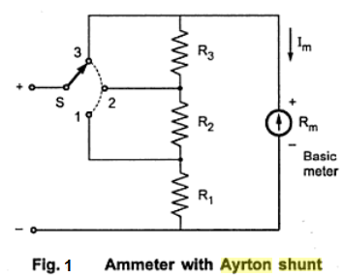](http://3.bp.blogspot.com/-mqN_ajulnUg/U5IJ13BfqqI/AAAAAAAANS8/LTPOlA5SphI/s1600/Snap36.png)

       The selector switch S, selects the appropriate shunt required to change the range of the meter. When the position of the switch is '1' then the resistance R1is in parallel with the series combination of R2, R3and Rm. Hence current through the shunt is more than the current through the meter, thus protecting the basic meter. When the switch is in the position '2', then the series resistance of R1 and R2 is in parallel with the series combination of R3and Rm. The current through the meter is more than through the shunt in this position. In the position '3', the resistances R1, R2and R3are in series and acts as the shunt. In this position, the maximum current flows through the meter. This increases the sensitivity of the meter.

       The voltage drop across the two parallel branches is always equal.

       Thus, IshRsh= ImRm

       But in position 1, R1is in parallel with R2+ R3+ Rm

[http://4.bp.blogspot.com/-Zs2bdrf9Os8/U5IKxbdNnII/AAAAAAAANTE/XOx1nuFsRiI/s1600/Snap37.png](http://4.bp.blogspot.com/-Zs2bdrf9Os8/U5IKxbdNnII/AAAAAAAANTE/XOx1nuFsRiI/s1600/Snap37.png)

       where I1is the first range required.

       In position 2, R1+ R2is in parallel with R3+ Rm.

[http://1.bp.blogspot.com/-QaFc4FkJl0o/U5ILTnWLbqI/AAAAAAAANTM/7T84dL_upvo/s1600/Snap38.png](http://1.bp.blogspot.com/-QaFc4FkJl0o/U5ILTnWLbqI/AAAAAAAANTM/7T84dL_upvo/s1600/Snap38.png)

       where I2is the second range required.

       In position 3, R1+ R2+ R3is in parallel with Rm.

[http://1.bp.blogspot.com/-Q5bakprZbNc/U5ItbIs9ZWI/AAAAAAAANTc/hNkhpS5Awb4/s1600/Snap39.png](http://1.bp.blogspot.com/-Q5bakprZbNc/U5ItbIs9ZWI/AAAAAAAANTc/hNkhpS5Awb4/s1600/Snap39.png)

       where I3is the third range required.

       The current range I3is the minimum while I1is maximum range possible. Solving the equations (1), (2) and (3) the required Ayrton shunt can be designed.

[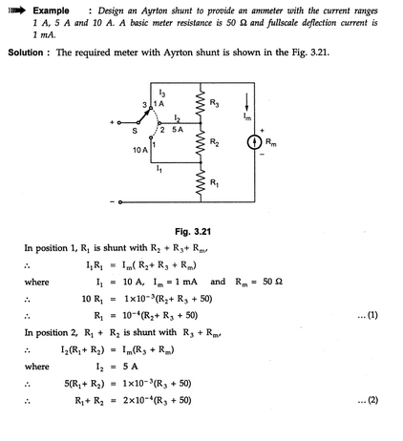](http://4.bp.blogspot.com/-Lpkg9l2nTqI/U5It-MPrxxI/AAAAAAAANT0/HYQEoFa38M8/s1600/Snap40.png)

[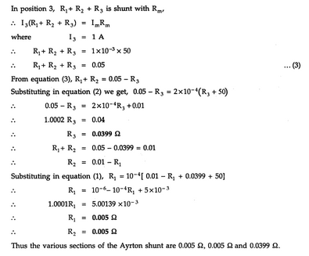](http://2.bp.blogspot.com/-LralWrDy7fI/U5ItsJ-lNbI/AAAAAAAANTk/I8veJGbGHdc/s1600/Snap41.png)

Precautions to be Taken While Using an Ammeter

       The following precautions must be taken while using an ammeter.

1) As the ammeter resistance is very low, it should never be connected across any source of e.m.f. Always connect an ammeter in series with the load.

2) The polarities must be observed correctly. The opposite polarities deflect the pointer in opposite direction against the mechanical stop ans this may damage the pointer.

3) While using multirange ammeter, first us e the highest current range and then decrease the current range until sufficient deflection is obtained. So to increase the accuracy, finally select the range which will give the reading near full scale deflection.

### 2.8.Basic D.C. Voltmeter:

The basic d.c. voltmeter is nothing but a PMMC D'Arsonoval galvanometer. The resistance is required to be connected in series with the basic meter to use it as a voltmeter.

This series resistance is called a multiplier. The main function of the multiplier is to limit the current through the basic meter so that the meter current does not exceed the full scale deflection value. The voltmeter measures the voltage across the two points of a circuit or a voltage across circuit component. The basic d.c. voltmeter is shown in the Fig. 2.7.

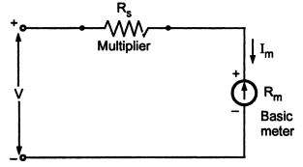

Fig.2.7.Basic D.C. Voltmeter

The voltmeter must be connected across the two points or a component, to measure the potential difference, with the proper polarity.

       The multiplier resistance can be calculated as:

        Let         Rm= Internal resistance of coil i.e. meter

                      Rs= series multiplier resistance

                      Im= full scale deflection current

                      V   = full range voltage to be measured

       From Fig 1,  **...**V = Im (Rm+ Rs)

**...**V  =  ImRm+ Im  Rs

**...**ImRs= V -  Im Rm

[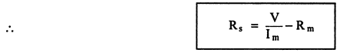](http://1.bp.blogspot.com/-CecoN4K2Hks/U7J3wu3L9UI/AAAAAAAANUQ/YpwQ9lQoBdk/s1600/M3.png)

       The multiplying factor for multiplier is the ratio of full range voltage to be measured and the drop across the basic meter.

       Let    v = drop across the basic meter =  ImRm

                m = multiplying factor = V/v

[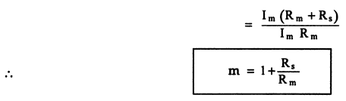](http://2.bp.blogspot.com/-Mo2N7Y7aA8s/U7J4DS1gIrI/AAAAAAAANUY/PUvJlTUJyXk/s1600/M4.png)

       Hence multiplier resistance can also be expressed as,

                               Rs= (m-1)

       Thus to increase the range of voltmeter 'm' times, the series resistance is (m-1) times the basic meter resistance. This is nothing but extension of ranges of a voltmeter.

**2.9. Multirange Voltmeter:**

## C:\Users\HP STORES\Desktop\cvcvc.png

Fig..Multirange voltmeter



## 2.10.Ohmmeter:

The ohmmeter is a convenient direct reading device for [measurement of resistance](http://myclassbook.org/measurement-of-resistance/). These instruments have a low degree of accuracy. The statement regarding to the accuracy is not intended in an unfavorable sense. There is a wide field of application for this instrument in determining the approximate value of resistance. An ohmmeter is useful for determining the approximate resistance of circuit components such as heater elements or machine field coils, measuring and sorting of resistors used in electronic circuits, checking of semiconductor diodes and for checking of continuity of circuit.

It is also useful in laboratories as an aid to a [precision bridge](http://myclassbook.org/schering-bridge-measurement-of-capacitance/), for it can help to know the [approximate value of resistance](http://myclassbook.org/kelvin-double-bridge-method-for-low-resistances/) which can save time in balancing the bridge.

**2.10.1.Series type ohmmeter:**

A D’ Arsonval movement is connected in series with a resistance R1 and a battery which is connected to a pair of terminals A and B, across which the unknown resistance is connected. This forms the basic type of series ohmmeter, as shown in Fig. 2.8 (a).

The current flowing through the movement then depends on the magnitude of the unknown resistance. Therefore, the meter deflection is directly proportional to the value of the unknown resistance.

**R1 = current limiting resistance**

**R2 = zero adjust resistance**

**V = battery**

**Rm= meter resistance**

**RX= unknown resistance**

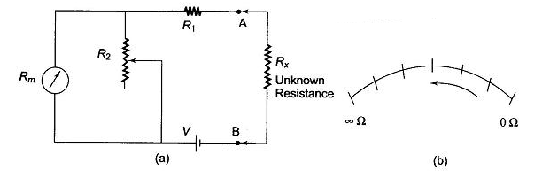

### **Fig.2.8.(a)Series type ohmmeter (b)Dial of series ohmmeter**

### **Calibration of the** [Series Type Ohmmeter](http://www.eeeguide.com/series-type-ohmmeter/):

To mark the “0” reading on the scale, the terminals A and B are shorted, i.e. the unknown resistance Rx= 0, maximum current flows in the circuit and the shunt resistance R2 is adjusted until the movement indicates full scale current (Ifsd). The position of the pointer on the scale is then marked “0” ohms.

Similarly, to mark the “∞” reading on the scale, terminals A and B are open, i.e. the unknown resistance Rx = ∞, no current flow in the circuit and there is no deflection of the pointer. The position of the pointer on the scale, is then marked as “∞” ohms.

By connecting different known values of the unknown resistance to terminals A and B, intermediate markings can be done on the scale. The accuracy of the instrument can be checked by measuring different values of standard resistance, i.e. the tolerance of the calibrated resistance, and noting the readings.

A major drawback in the series ohmmeter is the decrease in voltage of the internal battery with time and age. Due to this, the full scale deflection current drops and the meter does not read “0” when A and B are shorted. The variable shunt resistor R2 across the movement is adjusted to counteract the drop in battery voltage, thereby bringing the pointer back to “0” ohms on the scale.

It is also possible to adjust the full scale deflection current without the shunt R2 in the circuit, by varying the value of R1 to compensate for the voltage drop. Since this affects the calibration of the scale, varying by R2 is much better solution. The internal resistance of the coil Rm is very low compared to R1. When R2 is varied, the current through the movement is increased and the current through R2 is reduced, thereby bringing the pointer to the full scale deflection position.

The series ohmmeter is a simple and popular design, and is used extensively for general service work.Therefore, in a series ohmmeter the scale marking on the dial, has “0” on the right side, corresponding to full scale deflection current, and “∞” on the left side corresponding to no current flow, as given in Fig. 2.8 (b).

Values of R1and R2 can be determined from the value of Rx which gives half the full scale deflection.

[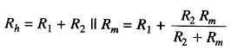](http://www.eeeguide.com/wp-content/uploads/2017/01/Series-Type-Ohmmeter-1.jpg)

where

Rh = half of full scale deflection resistance.

The total resistance presented to the battery then equals 2Rh and the battery current needed to supply half scale deflection is Ih=V/2Rh..

To produce full scale current, the battery current must be doubled.

Therefore, the total current of the ckt, It=V/Rh

The shunt current through R2 is given by I2=It-Ifsd

The voltage across shunt, Vsh, is equal to the voltage across the meter.

Therefore

[Series Type Ohmmeter](http://www.eeeguide.com/wp-content/uploads/2017/01/Series-Type-Ohmmeter-2.jpg)

Therefore

[Series Type Ohmmeter](http://www.eeeguide.com/wp-content/uploads/2017/01/Series-Type-Ohmmeter-3.jpg)

But

[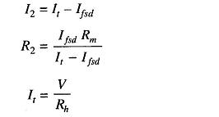](http://www.eeeguide.com/wp-content/uploads/2017/01/Series-Type-Ohmmeter-4.jpg)

Therefore

[Series Type Ohmmeter](http://www.eeeguide.com/wp-content/uploads/2017/01/Series-Type-Ohmmeter-5.jpg)

Therefore

[Series Type Ohmmeter](http://www.eeeguide.com/wp-content/uploads/2017/01/Series-Type-Ohmmeter-6.jpg)

As

[Series Type Ohmmeter](http://www.eeeguide.com/wp-content/uploads/2017/01/Series-Type-Ohmmeter-7.jpg)

Therefore

[Series Type Ohmmeter](http://www.eeeguide.com/wp-content/uploads/2017/01/Series-Type-Ohmmeter-8.jpg)

Hence

[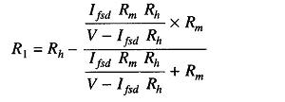](http://www.eeeguide.com/wp-content/uploads/2017/01/Series-Type-Ohmmeter-9.jpg)

Therefore

[Series Type Ohmmeter](http://www.eeeguide.com/wp-content/uploads/2017/01/Series-Type-Ohmmeter-10.jpg)

 Hence, R1 and R2 can be determined.

## 2.10.2.Shunt type Ohmmeter

In this type of meters we have a battery source and an adjustable resistor is connected in series with the source. We have connected the meter in parallel to the resistance which is to be measured. There is a switch by the use of which we can on or off the circuit. The switch is opened when it is not in use. When the resistance to be measured is zero, the terminals A and F are shorted so the [current](https://www.electrical4u.com/electric-current-and-theory-of-electricity/) through the meter will be zero. The zero position of the meter denotes the resistance to be zero. When the [resistance](https://www.electrical4u.com/electrical-resistance-and-laws-of-resistance/) connected is very high, then a small current will flow the terminal AF and hence full scale current is allowed to flow through the meter by adjusting the series resistance connected with the battery. So, full scale deflection measures very high resistance. When the resistance to be measured is connected between A and F, The pointer shows a deflection by which we can measure the resistance values. In this case also, the battery problem may arise which can be counteracted by adjusting the resistance. The meter may have some error due to its repeated use also.

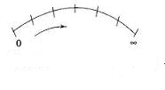

Fig.2.9.Dail of shunt type ohmmeter

